It focused on selecting suitable AI models and designing the foundational architecture of the EduGenie Learning Assistant. The objective of this activity was to ensure efficient educational assistance, modular development, and smooth integration between frontend, backend, and AI-powered functionalities.
For advanced educational functionalities such as Question Answering (Q&A), Summarization, Quiz Generation, and Personalized Learning Recommendations, Google Gemini 1.5 Pro was selected through API integration. Gemini 1.5 Pro was chosen because of its advanced reasoning capabilities, contextual understanding, structured response generation, and cloud inference support. The model enables EduGenie to generate intelligent and human-like educational content while maintaining high accuracy and efficiency across multiple learning tasks.
For concept explanation functionality, LaMini-Flan-T5-783M was selected as the local lightweight AI model. This model is instruction-tuned and specifically suitable for generating simplified explanations for complex educational topics. Since the model is CPU-compatible and lightweight, it improves local execution efficiency and reduces dependency on cloud resources for simpler tasks. The model helps learners understand difficult concepts in a concise, beginner-friendly, and highly readable manner.
Along with model selection, a modular folder architecture was designed to organize the project efficiently. The architecture separated backend modules, frontend resources, AI functionalities, and dependency management into independent files for better scalability, maintainability, and debugging.
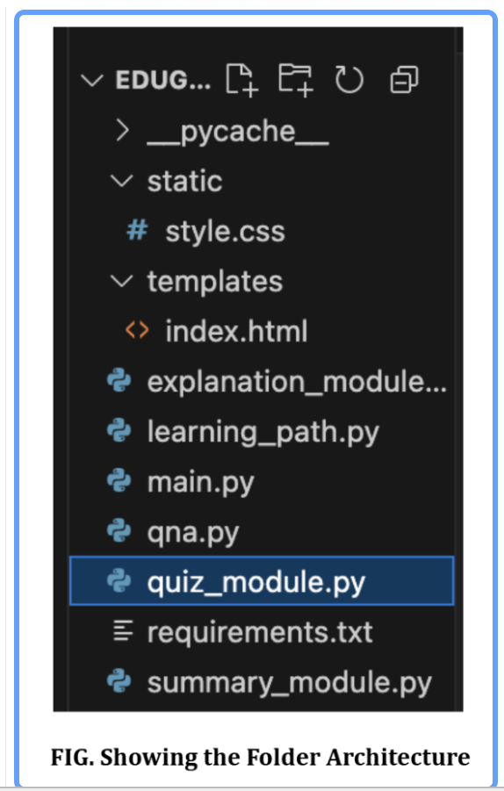
The folder structure included dedicated Python modules such as:
qna.py for Question Answering
explanation_module.py for concept explanation
quiz_module.py for quiz generation
summary_module.py for summarization
learning_path.py for personalized learning recommendations
The main.py file acted as the central FastAPI application responsible for routing and backend integration. Frontend resources were managed through the templates and static folders containing index.html and style.css, respectively. Additionally, the requirements.txt file stored all the required Python dependencies needed to run the EduGenie application successfully.

